4Wheel Underground

3Link/79-95
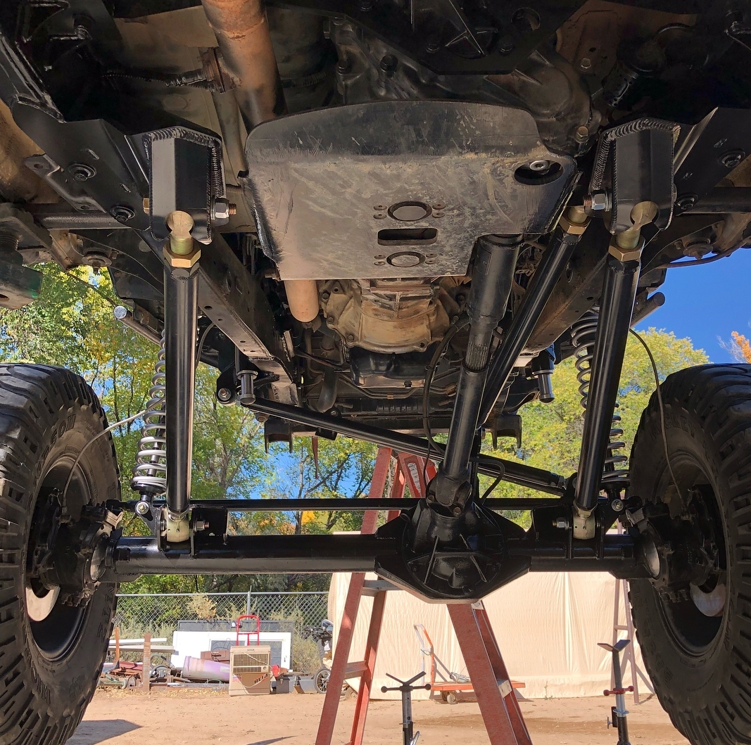
- There are many details to look at and work through when installing a front 3link. So the 1st rule is to slow down and be patient.

- The 2nd rule is to never weld anything until the entire kit is mocked up correctly.

- 3rd rule is your Tie Rod MUST be flipped to the underside of your steering arm if you have an after market leaf sprung steering arm. How you do so is up to you.

- Bracing of the frame is a 100% “MUST”!! Brace the frame from body mount in front of the steering box back to nearly the A pillar body mount. Top, bottom and outside strongly recommended.

- Recommended frame height during installation is 30”s while on jack stands. This is so you can freely cycle the suspension with out interference from the ground. You do not have to set the vehicle this high, it is only a recommendation.
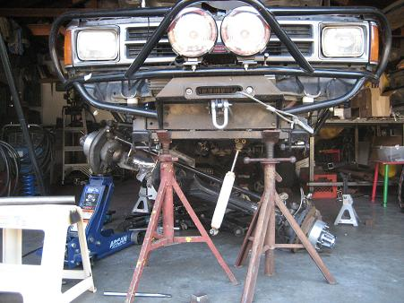
(fig.1)

- You will have to grind or cut off many brackets from your frame. Any and all IFS components must be removed as well as the factory T-Case crossmember brackets.

- Your lower link frame side brackets go where your T-Case crossmember used to. But in order for it to fit you must bend the large frame backing plate to sit accordingly. (fig.2)
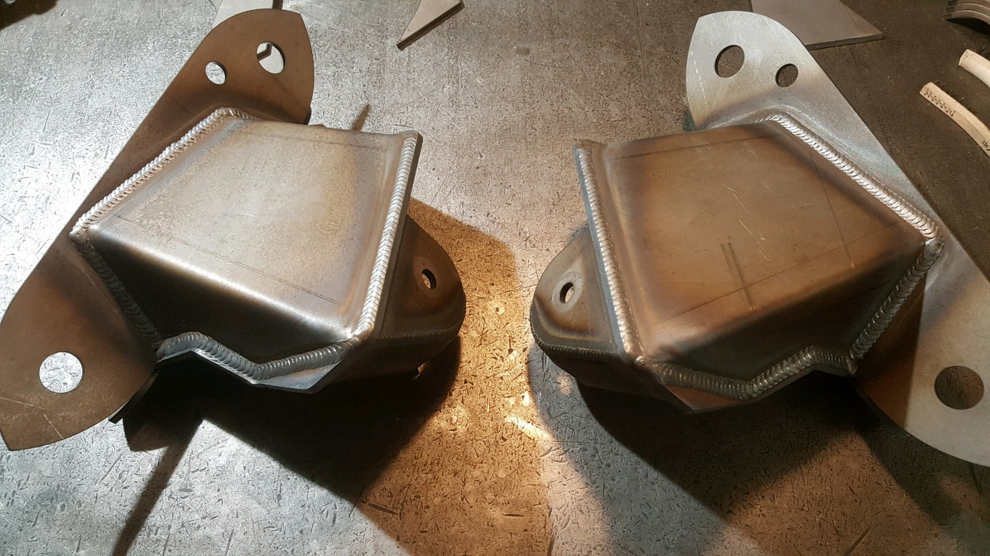
(fig.2)

- 4WU 3link Frame brackets are to be installed in one place and one place only. Locating holes have been cut in to the bottom of these brackets to help you locate their position. The two holes in each of the lower link frame brackets should be centered or as close to centered as possible to the two factory holes in each side of the frame that used to mount the T-Case crossmember. If the holes on the brackets and frame don’t line up perfectly its not a big deal just get as close as possible. BUT DO NOT WELD IT IN YET. Use clamps or tack welds to hold it in place.
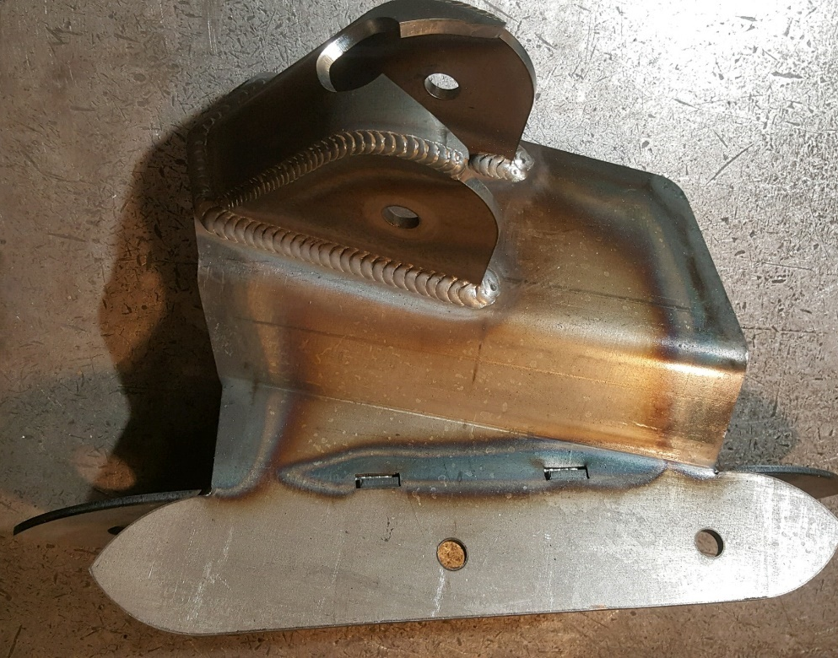
(fig.3)
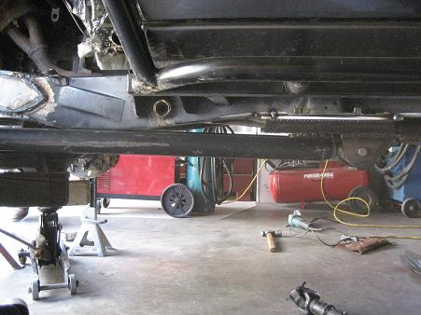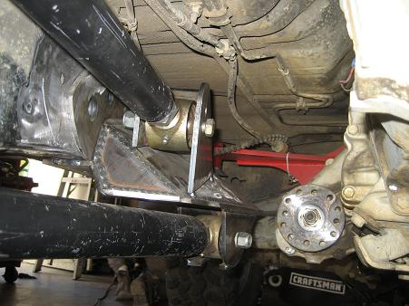
(fig.4) (fig.5)

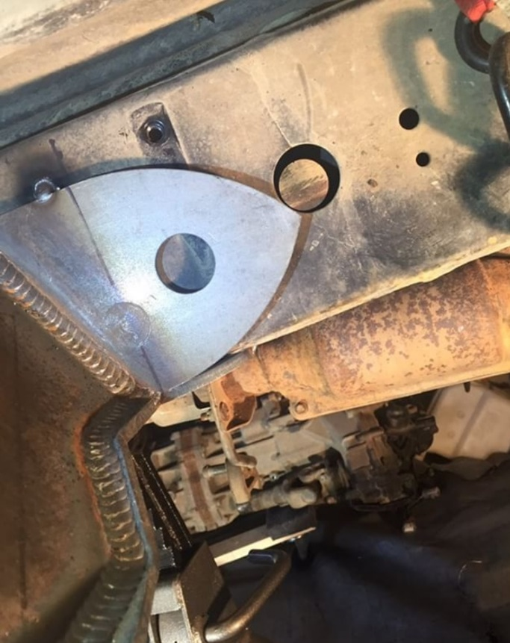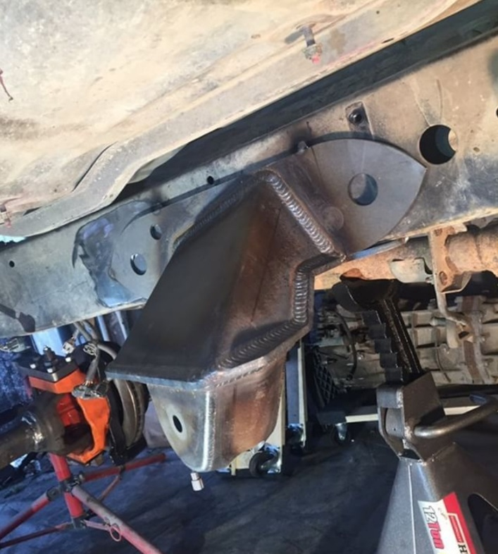
Frame locations shown for 96-2002 4Runners and 95 1/2-2004 Tacomas

- Your upper links frame side bracket should sit roughly in this location and in this orientation. Again only tack weld the piece in place for now. In fig.5 you can see the upper link is on the passenger side and should be for all 22R,22RE and 3VZ engines.

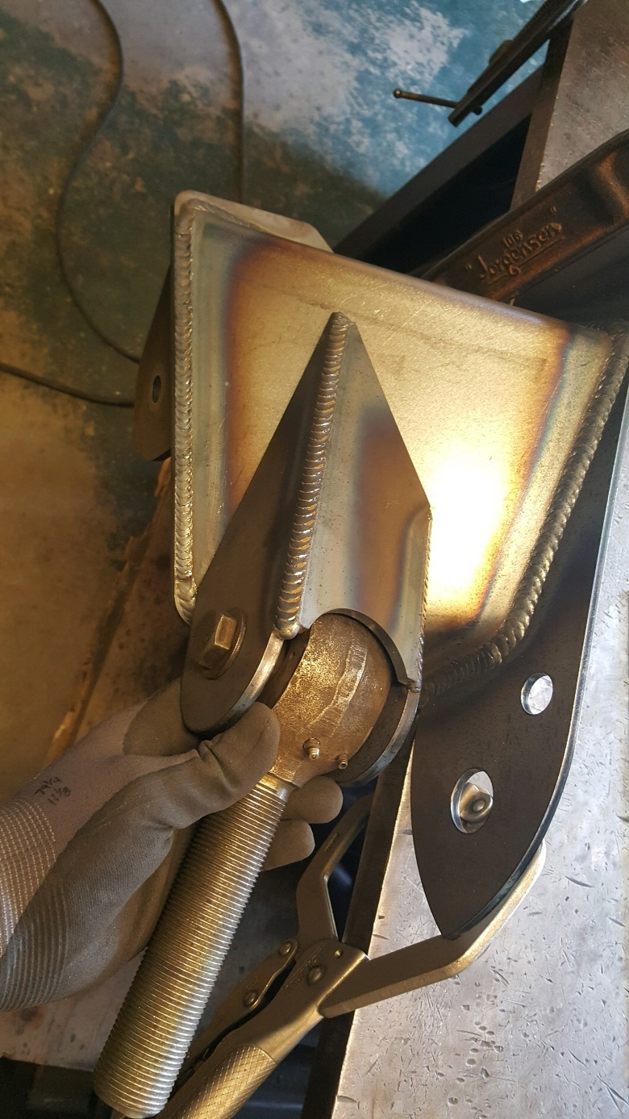
(fig.6) Shows the upper link on the driver side for all 2RZ,3RZ and 5VZ conversions.

- With your axle out of the truck and securely placed on jack stands of some kind, set your caster to 6* by placing an angle finder on the Trunion bearing race or steering arms. You should have at this point removed all factory brackets on your axle except for the steering stops. Your axle should also be clean and removed of any and all paint, dirt, grease, oil and rust.

- Time to locate the Axle side Panhard & Lower link bracket. On each lower link axle bracket there is a portion of the bracket that is to sit on top of the original steering stop. Make sure the steering stop reinforcements have been welded in place prior to mocking up any of the axle brackets. Please also note that this bracket is an EXTREMELY tight fit. If you NEED to clearance your passenger side steering arm please do so. (see fig.7)

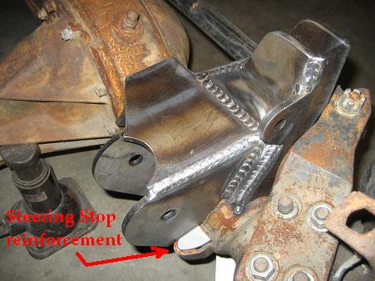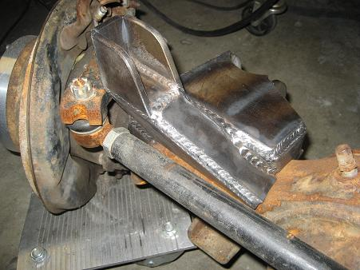
(fig.7) (fig.8)

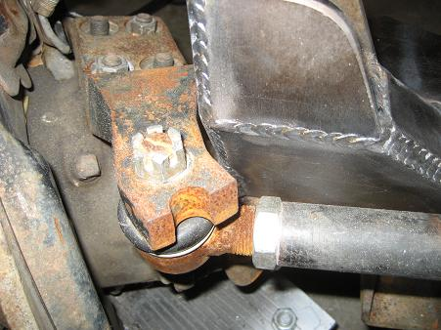
(fig.9)

- The other side of the axle is fairly easy to locate. With steering stop reinforcement in place and welded in, you will now be able to set the drive side lower link mount in place. If you put an angle finder on top of this bracket, it should read 4* if your cast is 6*. From center of this bracket to center of the other should roughly 34.5”s apart for mini trucks. Tacomas will be 39”.
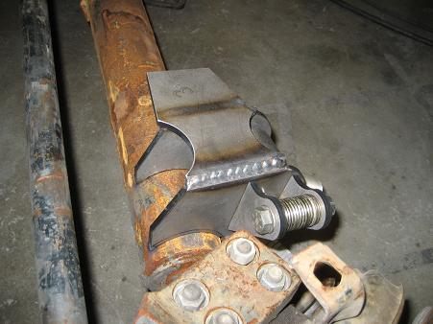
(fig.10)

- The upper link axle side bracket should be next. Its position is self-explanatory, however do not weld it in place yet. Some minor adjustment maybe necessary. If you have an upper link on the tube side set it so that the top mounting hole is 8”s above the lower link hole.
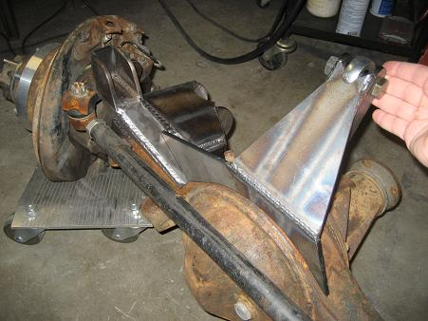
(fig.11)
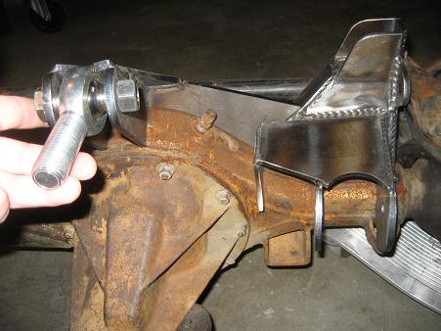
(fig.12)

- At this point your axle should look something like this. Remember not to weld anything yet.
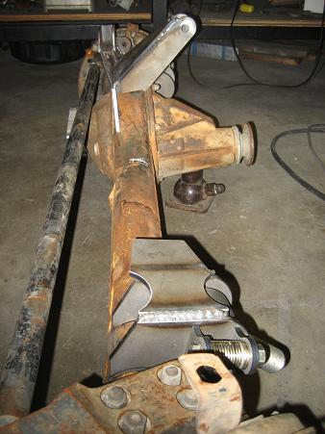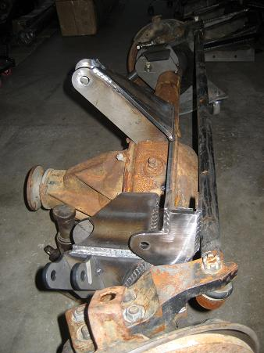
(fig.13)

- Move the axle back under the truck and place both the lower links and the upper links in place. You don’t need to tighten the nuts yet.

- A. Cycle the suspension up as far as it will go with the bump stops in place. If you are using AirBumps, make sure all the Nitrogen has been discharged. Poly Bumps will compress up to half their original length.The bump stop cans are only tacked in place so you need to remove those tack welds in order to set maximum up travel. Place the panhard frame side bracket on the drive side rail. During full compression of the suspension the panhard frame side bracket should nestle down between the axle side lower link brackets as depicted in fig.14. Please note that steps can be made in order gain additional up travel. (example) bend the upper link where it interferes with the clutch slave, or notching of frame where the draglink or panhard make contact. The more up travel you set into the truck the lower the vehicle will sit at ride height.

- B. During this section your goal is to make sure that full steer lock to lock doesn’t interfere with the tie rod and never hits the head of the bolt for your Panhard.

(Note) depending on your installation of the steering box and how far forward you move the axle, you may have to relocate your steering box further forward. You never want the tie rod and drag link to contact each other.

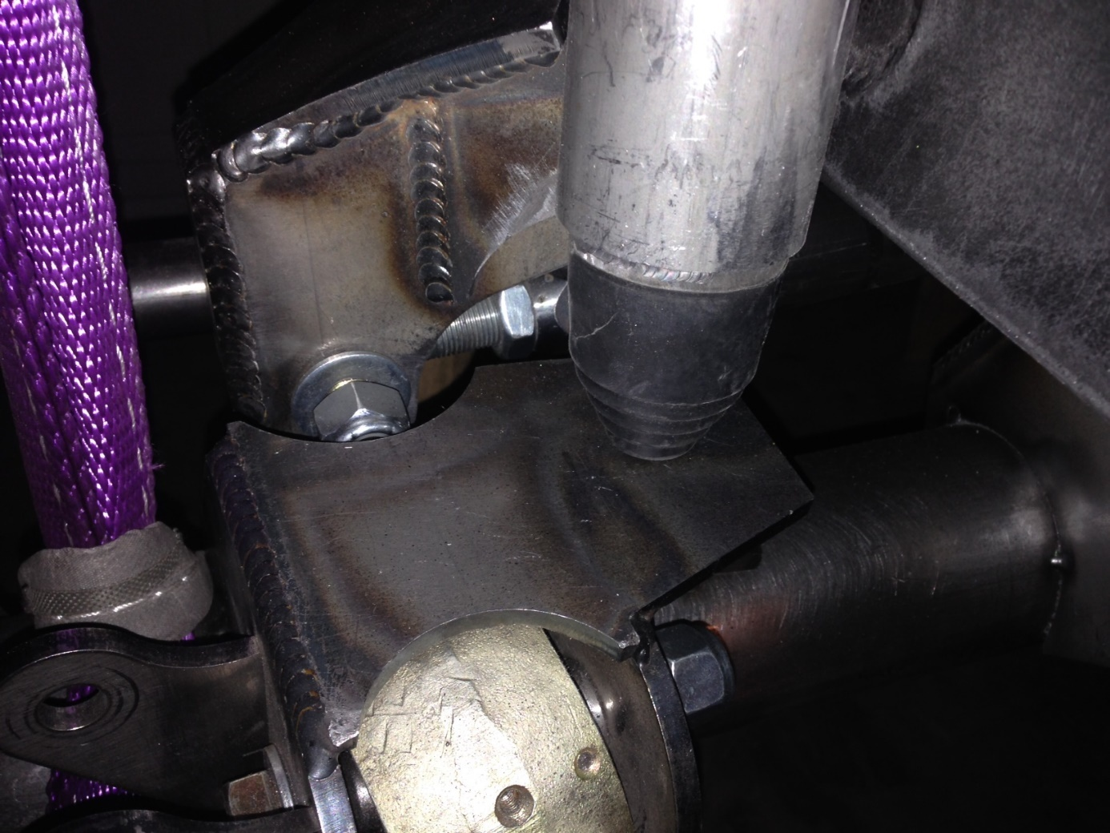
(fig.14)

- Mocking up your bump stop cans with your air bumps. Both of your bumps stops should be all but ¼” compressed when max compression is reached. Max compression should be just before your steering or Panhard Bar gets into your oil pan. Again, in order to check and measure this, your air bumps must be discharged of nitrogen.

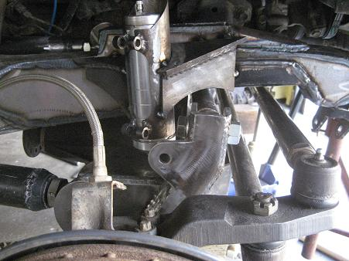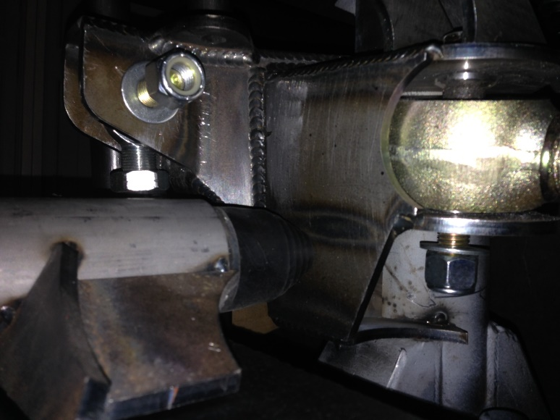
(fig.15) (fig. 16)

- When viewing the front of the vehicle and at ride ht., both the Panhard and Drag-Link should be perfectly parallel to each other. Tack weld shock mount taps in the position indicated in fig. 15. And set them 1.5”s apart from each other. (see fig.15)

- With “A” tire on one side of the axle, cycle your suspension fully up and the other down. Stop upward travel when your tires hit the insides of your fenders or battery box. Now with your Coil-Overs discharged of nitrogen and with only “ONE” spring on, bolt them up to the axle. Do so on both sides of the axle, both the extended side and the compressed side. The tops of each shock should be the same distance from the ground as well as the inside of the engine bay front to back and side to side. Be certain the extended shock isn’t touching the frame and the compressed shock isn’t interfering with the tire. Now fully weld every bracket 100% around all possible area’s.

(Note) During articulation, you may find the bump stops are not being used. This is intended and normal. Bump stops are largely used for compression of the axle during which both sides of the axle compress at the same time. Your shocks come with bumps on them, so you will not hurt the shocks by doing this.

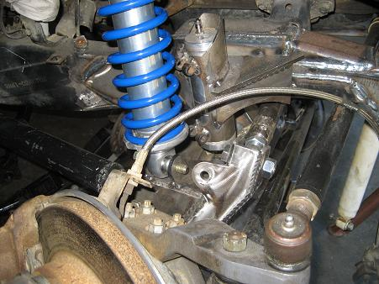
(fig.17)
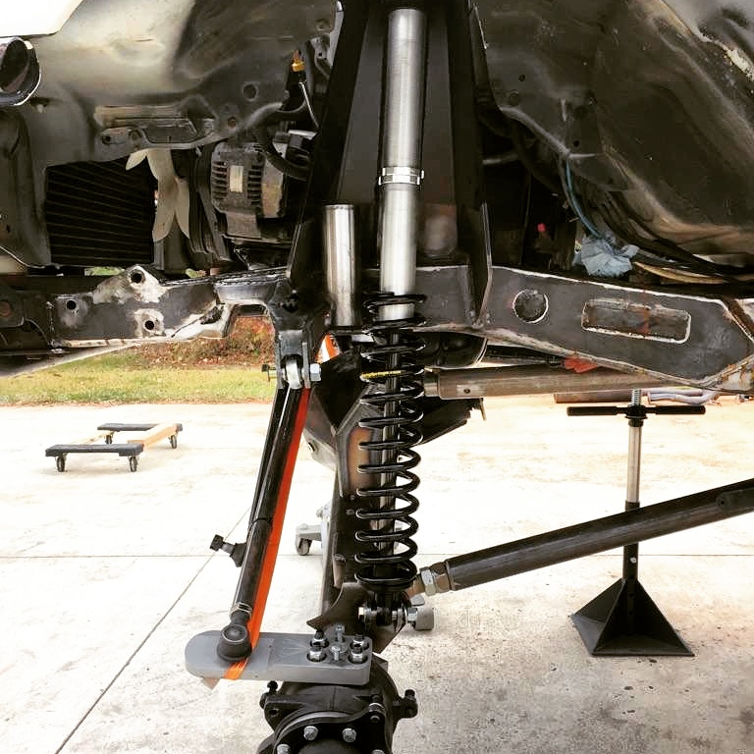

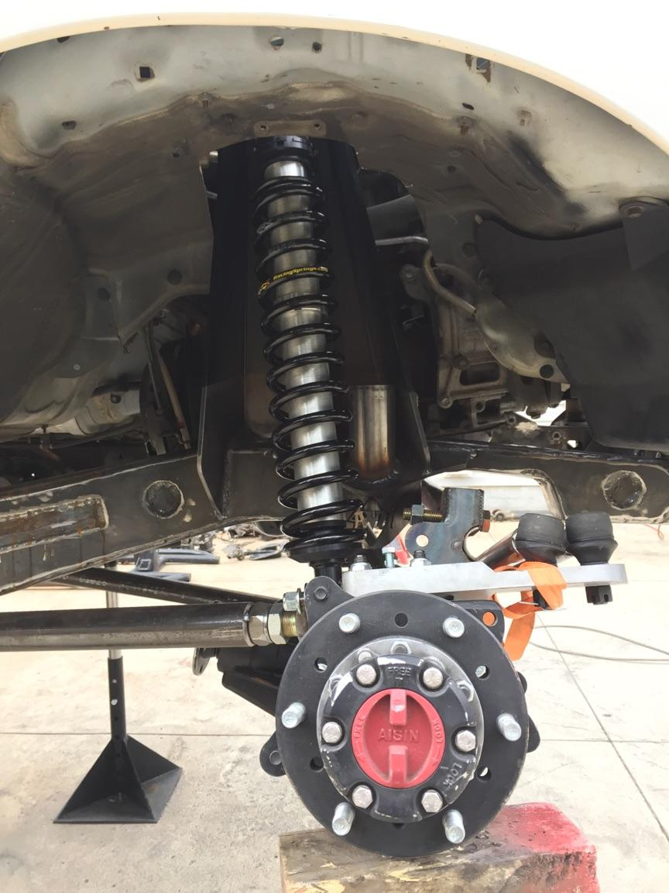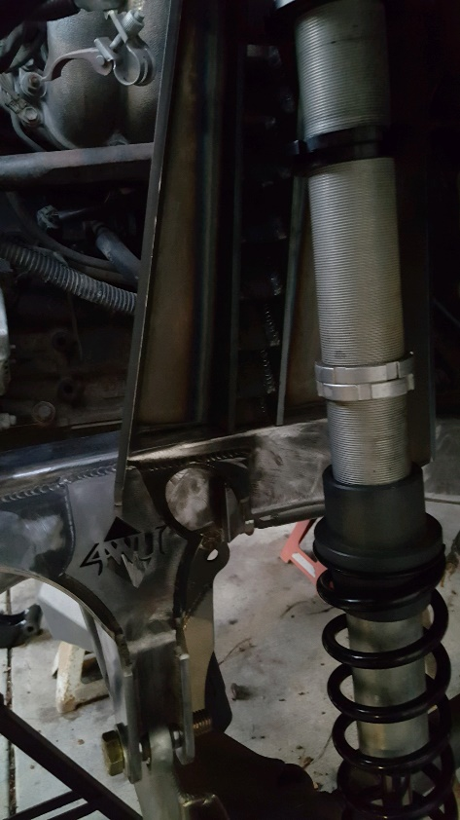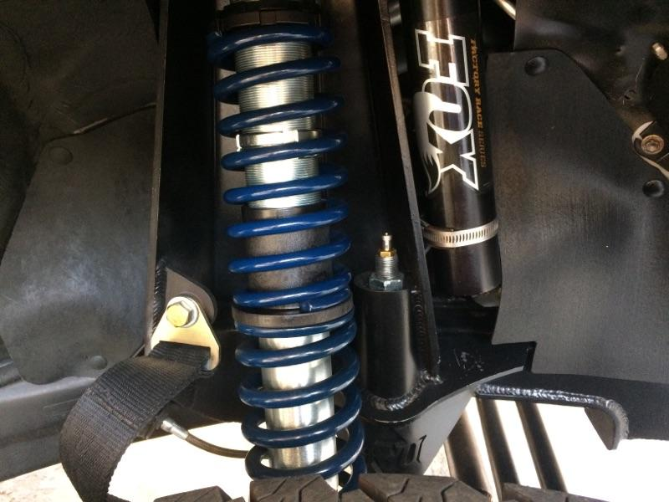

(fig.18)
Installation of shock towers should lean out away from the engine as much as clearances allow. Check tire to coilover clearances during articulation travel for referencing final tower locationl.
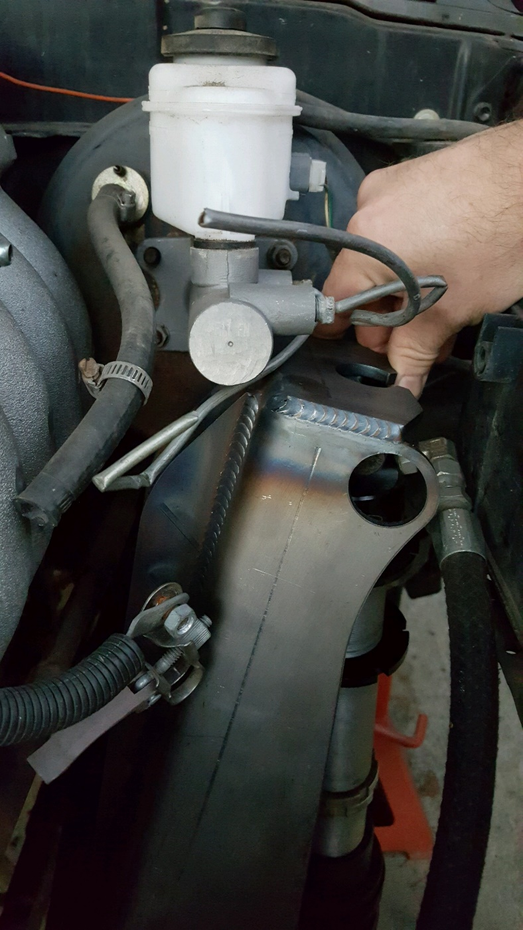

At full compression with all systems tacked in place your truck should be looking something like the following picture. Variations exist with different axle types and or if you’ve decided to use shock hoops and not towers.
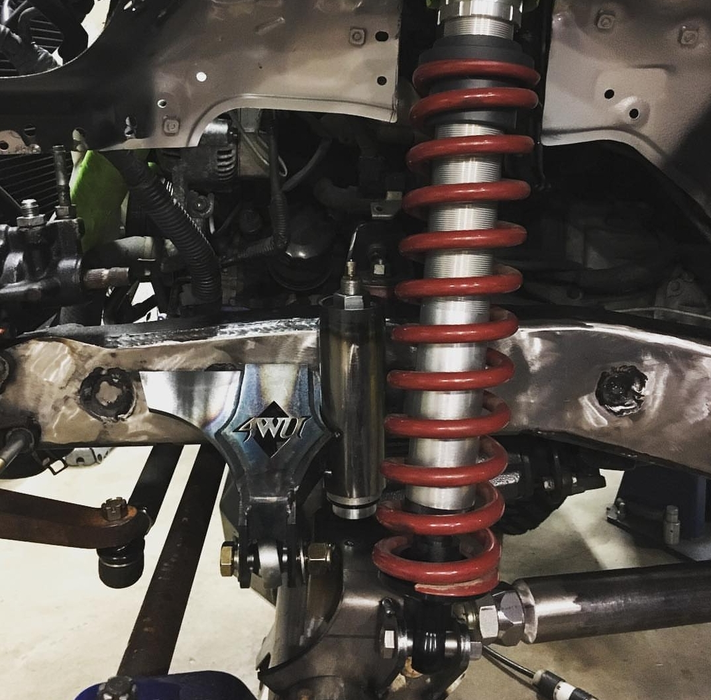

Proper weld prep for link arms should look like this

